1© Copyright Broadsword Interactive 1998

Car Physics
This document is a brief description of the physics used in the Spirit of Speed game.

Jim Finnis (jcf@broadsword.co.uk)
Revision: 0.1

Created: 12/1/99
Last Revised: 4/2/99
Document State: Draft

Phase One – Moving in a Straight Line
In this phase of the physics implementation, the following features are implemented:

Engine and transmission
The engine model works as follows:

- The car velocity in converted to transmission revs (if the driving wheels have grip).
- If the clutch is engaged (currently it automatically engages at about 300 rpm), transmission revs are converted to engine revs through the inverse gearbox function. There are 3-5 gears, with user-variable ratios.
- The engine revs are decreased through engine friction.
- The engine revs are increased by some function of the throttle setting.
- If the clutch is engaged, the engine revs are converted back to transmission revs through the gearbox function.
- The transmission revs are converted into car velocity (if the driving wheels have grip).
- The rest of the physics (collisions, inertia, friction, turning) affects the velocity.

Linear motion and collisions
The car is simply moved along its current velocity through the world, and the velocity and position are modified if a collision occurs.

Centre-axis turning
In this first phase, the car is simply rotated around its y-axis when the steering wheel is turned.

Ground adherency
The car is forced to adhere to the ground in this phase of the physics in a very simplistic manner. Later phases will introduce more complex behaviour.

Phase Two – Turning Circle
Phase two involves making the car turn correctly. This involves detecting when the wheels are not in a straight line and in this case moving the car by rotating it around a given point, called the turning point, through such an angle as to translate it by the magnitude of its velocity vector.

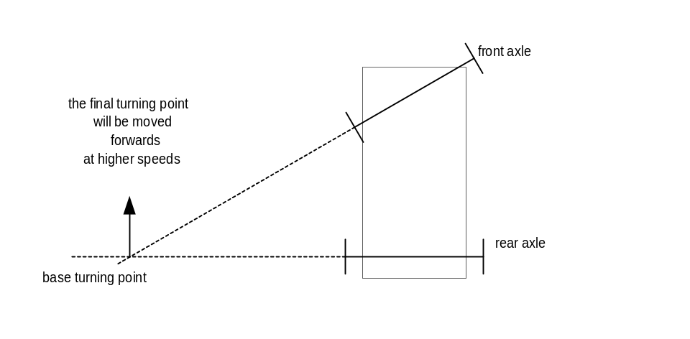
Therefore the turning point is:
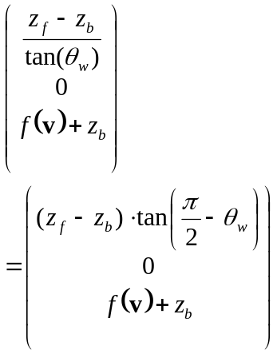

where z_{f} is the z coordinate of the front axle, z_{b} is the z coordinate of the back axle, θ_{w} is the wheel turn angle, v is the car’s velocity and f(v) is the function which determines how far the turning point is shifted forwards. Note that all coordinates are relative to the car.
The angle to turn the car through is determined thus:
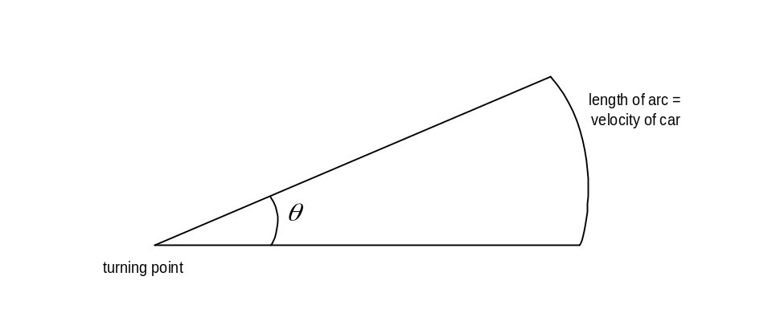
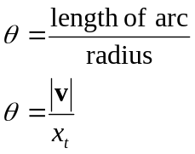

Where v is the velocity of the car and x_{t} is the x coordinate of the turning point.

The car’s movement is purely a rotation around a point; no translation component is used (although, of course, the matrix to perform this rotation will have a translational component).

Phase Three – Simple Collision
In this phase, the simple collision code is implemented.

Collision Detection
Each object has a collision hull made up of primitive shapes – currently spheres, lines and discs. A tool has been written to facilitate building these hulls. Cars are currently made up of a car body (comprising about eight shapes); and four wheels (made up of a single disc), as far as collisions are concerned. Detecting collisions between the primitive shapes and the triangles in the world is relatively efficient. The result of a positive collision detection the triangle our object is colliding with, a vector of collision, and a point.

Collision Resolution
Once a collision has been detected it must be resolved. This involves two stages:
- moving the object along the collision vector until it is out of collision;
- modifying the velocity.

The velocity is modified by reflecting it around the normal of the colliding triangle:

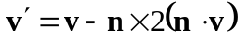

This collision resolution will be improved in Phase Five.

Phase Four – Loss of Grip, Multiple Surfaces
Phase three deals with detecting a loss of grip and simulating the effects.

Detection
Each tyre has a grip value ranging from 0 (for no grip) to 1 (for full grip). The grip value is determined from several factors.

Each physics tick, each wheel’s direction is compared the forces acting upon it. These are calculated from the the velocity of the car, braking, and the spin rotational velocity (if the car is spinning). If the lateral force on the wheel goes above an empirically determined threshold, grip on that wheel is lost. If the lateral force subsequently goes below another threshold level, significantly lower than the first, grip is regained.

Effects of loss of grip
Once a wheel loses grip, it becomes increasingly likely that other wheels will also lose grip. Losing grip on the front wheels happens rarely, but if it does the result is usually minor apart from the loss of steering. The effect of losing grip on one driving wheel depends on the type of differential used. In a normal slip differential, the engine will over-rev and the other driving wheel will lose drive because the drive is being transmitted to the wheel which has lost grip. Other differentials, with different degrees of slip, will leave some drive in the wheel which is still on the ground, resulting in a rotational force.

If both back wheels lose grip, the back end of the car slides away – that is, a rotational effect comes into play on the car, around the centre of the front axle (since the front wheels still have grip). Generally, the car’s velocity is left unchanged (at least until the back wheels regain grip and are facing in a different direction). If a front wheel then loses grip owing to the extra lateral forces introduced by the slide, the rotational axis changes to the remaining gripping wheel. When this last wheel loses grip, the axis changes to the centre of the car. Grip is usually regained a wheel at a time, with the two front wheels gripping nearly at the same time and the rear wheels following some time afterwards.

Different surfaces
Different surfaces have different grip thresholds, so that driving with even one wheel on wet road will make the car more likely to slip.

Phase Five – Improved Collision Detection and Resolution.
The first problem examined in this phase is tunnelling. This occurs when an object moves so quickly that it moves from being out of collision on one side of a wall to being out of collision on the other, without having collided with any triangles in the wall. If we find that tunnelling is occuring in the game, we can replace the primitive shapes with speedboxes – versions of the shapes extended through space to encompass all the positions they would go through within the next tick.

Collision resolution will be improved by adding spin determination code – adding to the rotational velocity values used in the existing spin/slide code; and also code to handle catastrophic crashes.

Damage will also be added in this phase. Each collision point will be examined to determine the damage incurred on the car, and the car’s physical parameters and/or model will be modified accordingly.

In addition, car/car collision will be added in this phase. The resolution will be essentially the same, but the detection will be completely different. Each cars will have a “time to impact” table for each other car, giving the soonest possible time those cars could impact given their positions and velocities. Only pairs of cars within the minimum TOI will be tested. Testing will be done initially against bounding boxes, and then against collision hull shapes.

Phase Six – Suspension
In this phase, the effects of suspension on the car will be modelled. Graphically, this will involve changing the relative positions of the wheel and axle components of the car object in response to acceleration in the local y-axis of the car.

In handling the car, a soft suspension will cause the car to roll around corners, distributing the weight of the car toward the outside of the corner. This may cause loss of grip to the inside wheels. However, stiff suspension decreases grip on rough surfaces because the car will bounce more across the surface.

